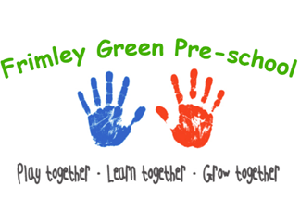
Health procedures
To be used alongside our other Healthy Eating and Lunch Box Policies.
Oral health
The setting provides care for children and promotes health through promoting oral health and hygiene, encouraging healthy eating, healthy snacks and tooth brushing.
- Fresh drinking water is always available and easily accessible.
- Sugary drinks are not served.
- Children use an open free-flowing cup and are discouraged from using a bottle.
- Only water and milk are served with morning snacks.
- Children are offered healthy nutritious snacks with no added sugar.
- Parents/carers are discouraged from sending in confectionary as a snack or treat.
- Staff follow the Infant & Toddler Forum’s Ten Steps for Healthy Toddlers.
- Children will be taught about the Dentist and their role in good oral health using books/discussion/role play/songs.
- Children will be provided with information about healthy eating for healthy teeth.
- Children will have the opportunity to help with snack preparation which can be used as a practical way to learn about healthy eating and oral hygiene.
- If possible, the setting will arrange visits from a Dentist/Dental nurse to talk with the children.

Practical ways to promote good oral hygiene at home
Promoting good oral health includes:
- Talking to children about the effects of eating too many sweet things
- Promoting regular toothbrushing at home – twice a day for 2 minutes using a fluoride toothpaste
- Encouraging children to visit the dentist regularly (twice a year is recommended)
- Encouraging parents to promote good oral health at home
- Supervised toothbrushing (There is no requirement in the EYFS to introduce supervised toothbrushing at pre-school and at Frimley Green Pre-school we will not be adopting this initiative). However, parents should supervise their child’s tooth brushing at home.
- Provide parents/carers with up-to-date research-based information regarding how to care for their child’s teeth – via leaflets/discussion/website/Facebook page and weekly updates.

Pacifiers/dummies
- Parents/carers are advised to stop using dummies/pacifiers once their child is 12 months old.
- Dummies that are damaged are disposed of and parents/carers are told that this has happened
There is no requirement for practitioners to assess oral health, although a child who presents with poor oral health is a concern which will prompt parents to be contacted and a referral to the Designated Safeguarding Lead.

Further guidance
Infant & Toddler Forum: Ten Steps for Healthy Toddlers www.infantandtoddlerforum.org/toddlers-to-preschool/healthy-eating/ten-steps-for-healthy-toddlers/
This policy was amended on 24th February 2025.

