Frimley Green Pre-school

Existing Injury Form****

This form to be completed by Parents or Carers when they bring a child to Preschool with a pre-existing injury.

This form will be held confidentially, only accessible to the child’s Key Person, the Manager and Social Services or OƒSTED, should they wish to see it.

Name of child

Date of Injury Date injury reported

Reported by

Nature of Injury

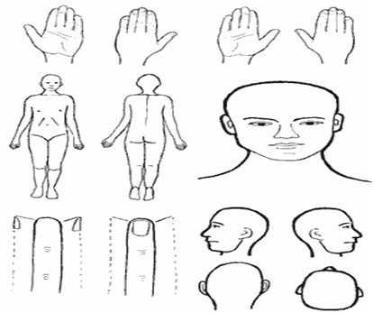

Any treatment or medical aid sought

Any ongoing care requested

Signature (Parent/Carer) Date

Signature (Preschool Manager) Date